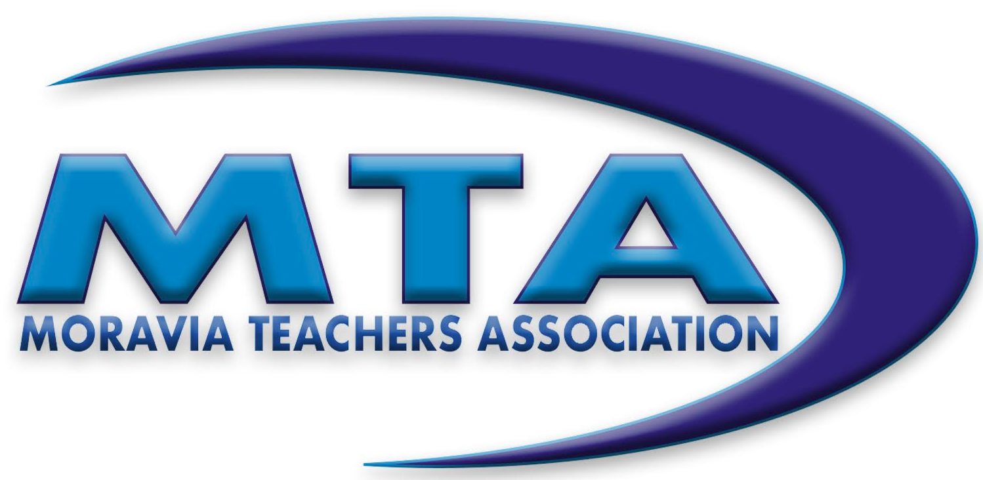

MORAVIA TEACHERS ASSOCIATION SCHOLARSHIP APPLICATION

**\*For Graduating Seniors who are not a child of a member of the MTA\***

# Student Name __________________________ Class Rank _____

**3½ Year Average__________**

**High School Academic Honors _________________________________________**

**High School Extracurricular Activities (list honors/awards) __________________**

**Community Service (Volunteer Work) ___________________________________**

**(over)**

**Paid Employment (list hours per week) _________________________________**

**Applicants must submit a letter of recommendation from a person not affiliated with MCS. Recommendations may be from an employer, fire chief, clergy, or others, but not parents.**

**College Attending Beginning Fall 2025 _________________________**

**Intended Major ___________________________________________**

**Deadline: Completed application must be in the Counseling Office by 3:00 PM on Friday, May 2, 2025.**